# Department of Computing

**CS471: Machine Learning**

**Class: BESE-7AB**

**Lab 03: Linear Regression with Multiple Variable**

**CL01: Apply Linear Predictor to Real world data**

**Date: 08-02-2019**

**Time: 10:00 am– 1:00 pm & 2:00 pm-5:00 pm**

**Instructor: Dr. Pakeeza Akram**

**Lab 03:** **Linear Regression with Multiple Variables**

**Introduction**

Linear regression with multiple variables.

<http://www.ritchieng.com/multi-variable-linear-regression/>

**Objectives**

Understand linear regression with multiple variables.

**Tools/Software Requirement**

Python 3, Matplotlib, Numy, Jupyter

**Task Description**

We have a file txt that contains the dataset for linear regression problem. The first column is the population of the city and the second column is the profit of having a store in that city. A negative value for profit indicates a loss.

Please see the Jupyter Notebook and open your ipynb file and complete the tasks 1-3 of Linear regression with multiple variable part.

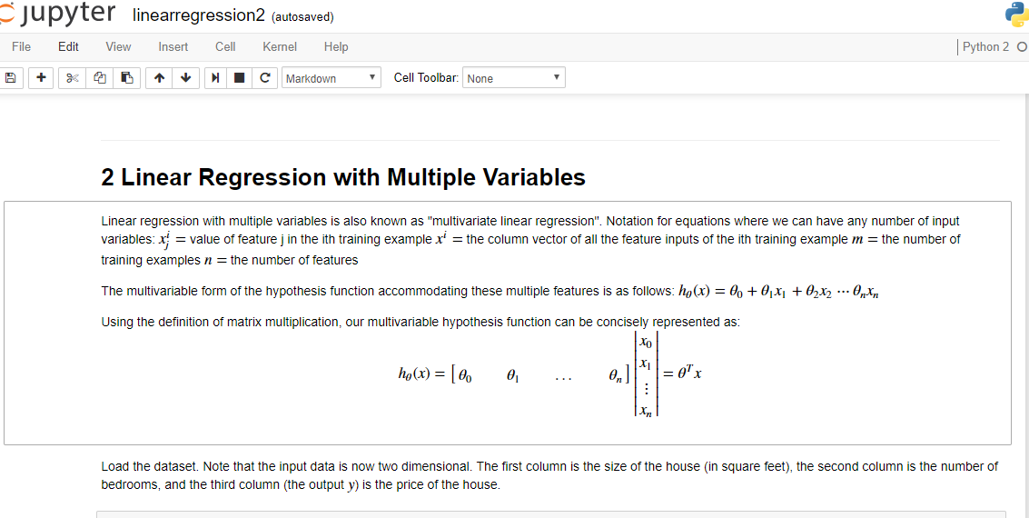

The Jupyter Notebook is an open-source web application that allows you to create and share documents that contain live code, equations, visualizations and narrative text. You can find information about Jupyter notebook at <http://jupyter.org/index.html>.



**Deliverable**

* Students are required to upload the lab task in solution in .ipynb format on LMS. Please note you are required to do task 1-3 for Section 2.
* The file name must contain your name and CMS ID in the following format. <Lab03_your CMS ID_your name.ipynb>